Factor Analysis Note

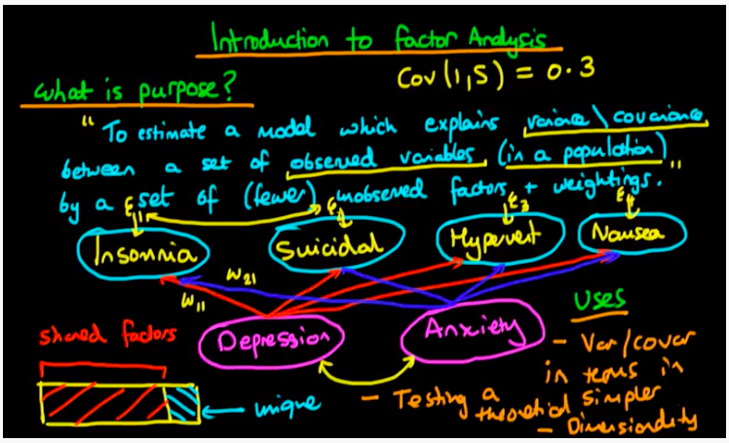

* Goal: use factor analysis to find hidden causes
  + Eg. Observations of each person’s insomnia, suicidal thoughts, hype, and nausea are collected, but they are all influenced by a person’s depression and anxiety degree with different weights
    - Depression and anxiety degree are not from observations
    - Use Factor Analysis to discover these hidden factors
* Each of the observed variable (like insomnia) has variance that can be separated to the shared factors (commonality) that explained by hidden factors (thus shared with other observed variables). It also has some portion of individual variance that is unique.
* **Factor Loading**:
  + Factor loading is basically the correlation coefficient for the variable and factor.
  + shows the variance explained by the variable on that particular factor.
  + In the SEM approach, as a rule of thumb, 0.7 or higher factor loading represents that the factor extracts sufficient variance from that variable.
* **Eigenvalues:**
  + Eigenvalues is also called characteristic roots.
  + shows variance explained by that particular factor out of the total variance.
  + From the commonality column, we can know how much variance is explained by the first factor out of the total variance.  For example, if our first factor explains 68% variance out of the total, this means that 32% variance will be explained by the other factor.
* **Factor score:**
  + The factor score is also called the component score.  This score is of all row and columns,
  + can be used as an index of all variables and can be used for further analysis.
  + can standardize this score by multiplying a common term.  With this factor score, whatever analysis we will do, we will assume that all variables will behave as factor scores and will move.